**DEPARTMENT OF INFORMATION TECHNOLOGY**

**COURSE CODE: DJS22ITL501 DATE: 14-08-2024**

**COURSE NAME: Artificial Intelligence Laboratory CLASS:TY-IT1**

**NAME: Anish Sharma ROLL:I011**

# EXPERIMENT NO. 1

**CO/LO:** Understand the fundamentals of artificial intelligence systems.

**AIM / OBJECTIVE: S**elect a problem statement relevant to AI.

i) Identify the problem ii) PEAS Description iii) Problem formulation

**DESCRIPTION OF EXPERIMENT:**

Tutorial exercise for

1. Design of Intelligent Systems using PEAS.
2. Problem Definition with State Space Representation.

* Student shall design the following agents using PEAS (describe them) and justify the environments for the same
* Robot soccer player
* Shopping for used AI books on the Internet
* Agent playing Crossword puzzle
* Bidding on an item in auction.
* (two examples of your choice)

Students shall formulate state space for the following problem.

* Water jug problem
* 4-Puzzle problem

**Explanation/Solutions (Design):**

* Robot soccer player

1. Performance measure: goals, handling of the ball, following rules and regulations, defensive actions
2. Environment: other players, goal post, pitch

The environment is highly dynamic and interactive, requiring the agent to make real-time decisions based on continuously changing inputs from both teammates and opponents. c) Actuators: robotic legs, speed controller, motors

d) Sensors: cameras, angle sensors, gyroscopes and accelerometers for balance.

• Shopping for used AI books on the Internet

1. Performance measure: book recommendation based on genre, cost, date, reviews and ratings
2. Environment: customer, seller, review sites

The internet environment is partially observable and involves multiple agents (buyers and sellers), making it essential for the agent to navigate uncertainty and competition.

1. Actuators: machine learning algorithm for recommendation, api for online marketplaces
2. Sensors: input devices like keyboard, reviews and rating analysis

• Agent playing Crossword puzzle

1. Performance measure: wide vocabulary, speed of solving, efficiency in using cues
2. Environment: crossword puzzle grid, including clues and word definition

The environment is deterministic and fully observable, making it ideal for logical reasoning and constraint satisfaction.

1. Actuators: algorithm to figure out answers, smart display, undo moves
2. Sensors: input of crossword and questions, text recognition

• Bidding on an item in auction.

1. Performance measure: analyzed bid, winning at lowest price, staying in budget, competing strategically
2. Environment: online auction platform with other bidders and a continuously changing price
3. Actuators: api or web automation tools for placing bids, timing of bid placing

The auction environment is partially observable and stochastic, requiring the agent to handle uncertainty, competition, and strategic timing. d) Sensors: time tracking, price monitoring

• Virtual try on

1. Performance measure: fits perfectly, size options, adjusts to lighting, color accuracy
2. Environment: user, online shopping platform, retailers

The environment is semi-dynamic because the user's appearance and lighting can change in realtime. It’s multi-agent involving interaction between the user, shopping platform, and retailers.

It’s partially observable because the system can't fully capture all real-world variables like exact fit and lighting conditions, relying instead on approximations. c) Actuators: smart display

d) Sensors: camera, angle recognizer

• Natural language to query

1. Performance measure: accurate query, selection of appropriate tables, formulating logical queries
2. Environment: database, natural language processing system

The environment is static as the database structure remains stable. It’s single-agent since the interaction is solely between the user and the query system. The environment is fully observable because the system has full access to the database schema, allowing accurate query formulation. c) Actuators: chat bot for text generation, connection to database, user interface

d) Sensors: database connection methods

* Water jug problem

State space of this problem can be descried as the set of ordered pairs of integers (X,Y) such that X represents the number of liters of water in 5L jug and Y for 3L jug.

Start state: (0,0) Goal state: (0,4)

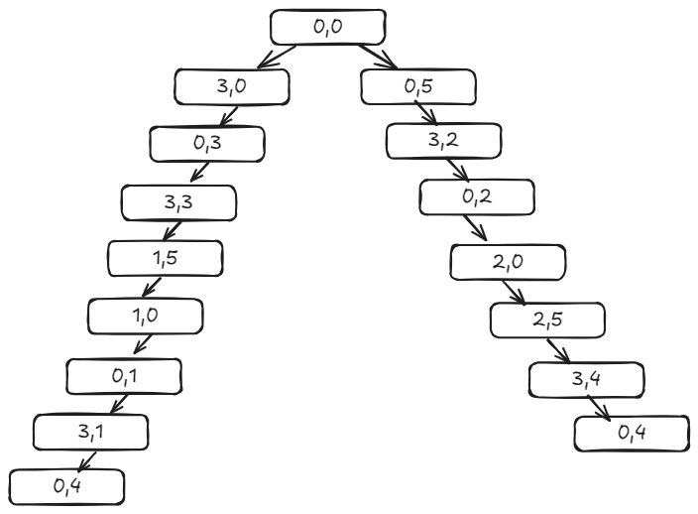

* 4-Puzzle problem

Given a 2×2 board with 4 tiles (each numbered from 1 to 3) and one empty space, the objective is to place the numbers to match the final configuration using the empty space. We can slide four adjacent tiles (left, right, above, and below) into the empty space.

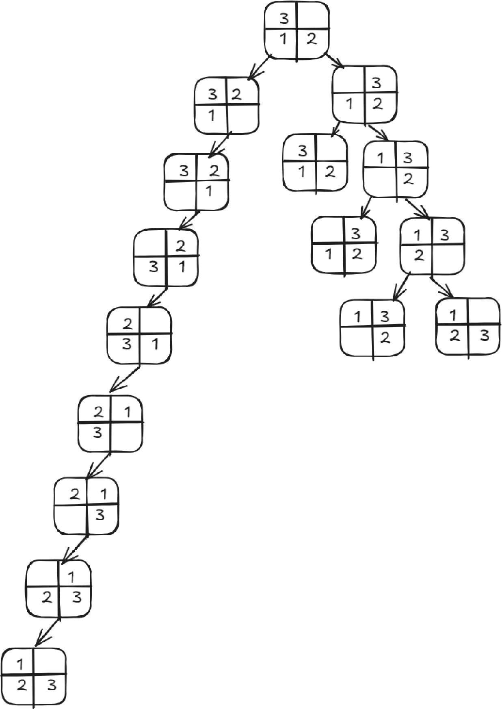

**OBSERVATIONS / DISCUSSION OF RESULT:**

The exercise of designing intelligent systems using the PEAS framework and formulating problems with state space representation emphasizes the structured approach needed to develop and analyse AI agents. By defining performance measures, environments, actuators, and sensors, we gain insights into the complexity of agent-based systems and the significance of aligning these components with the agent’s goals. The exercise of mapping problems like the Water Jug and 4-Puzzle into state spaces reinforces the importance of clear problem definition, enabling the application of search algorithms and leading to effective problem-solving strategies.

**CONCLUSION:**

In tis experiment we understood about designing of Intelligent Systems using PEAS and problem Definition with State Space Representation.

**REFERENCES:**

[1] Stuart J. Russell and Peter Norvig, “Artificial Intelligence A Modern Approach”, 2nd Edition, Pearson Education,1995.